MARKOV DECISION PROCESS (MDP)
Given a Markov decision process (MDP) with states S1, S2, and S3, and actions A1 and A2, with the following transition probabilities:
P(S2 | S1, A1) = 0.6,
P(S2 | S1, A2) = 0.4
P(S3 | S1, A1) = 0.2,
P(S3 | S1, A2) = 0.8
P(S1 | S2, A1) = 0.7,
P(S1 | S2, A2) = 0.3
P(S3 | S2, A1) = 0.5,
P(S3 | S2, A2) = 0.5
P(S1 | S3, A1) = 0.9,
P(S1 | S3, A2) = 0.1
P(S2 | S3, A1) = 0.4,
P(S2 | S3, A2) = 0.6

And rewards
(S1,A1,S2)=5,
R(S1,A2,S2)=10,
(S1,A1,S3)=−1,
(S1,A2,S3)=−5,
R(S2,A1,S1)=3,
R(S2,A2,S1)=7,
R(S2,A1,S3)=2,
R(S2,A2,S3)=1,
R(S3,A1,S1)=4,
R(S3,A2,S1)=6,
R(S3,A1,S2)=0, and
R(S3,A2,S2)=−2.
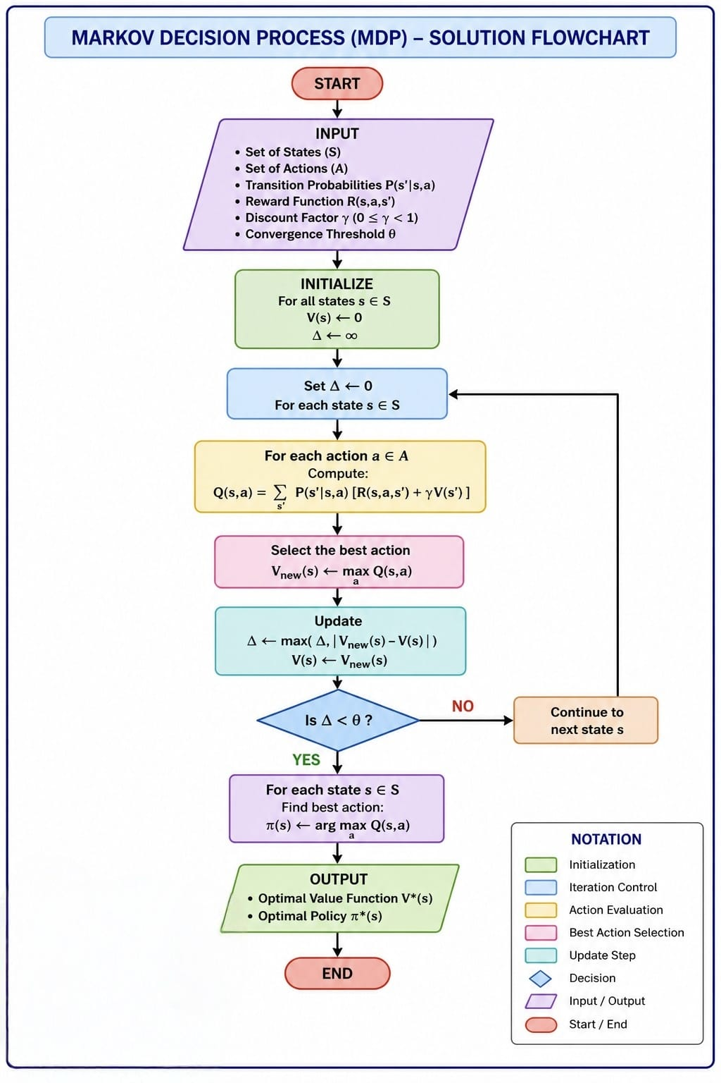
# MODULE 1
#############################

states <- c("S1","S2","S3")
actions <- c("A1","A2")

cat("Number of States :", length(states), "\n")
cat("Number of Actions:", length(actions), "\n\n")

cat("States:\n")
print(states)

cat("\nActions:\n")
print(actions)

# Transition Probabilities
transition <- data.frame(
CurrentState=c("S1","S1","S1","S1",
"S2","S2","S2","S2",
"S3","S3","S3","S3"),

Action=c("A1","A2","A1","A2",
"A1","A2","A1","A2",
"A1","A2","A1","A2"),

NextState=c("S2","S2","S3","S3",
"S1","S1","S3","S3",
"S1","S1","S2","S2"),

Probability=c(0.6,0.4,0.2,0.8,
0.7,0.3,0.5,0.5,
0.9,0.1,0.4,0.6)
)

cat("\nTransition Probabilities\n")
print(transition)

# Rewards
reward <- data.frame(
CurrentState=c("S1","S1","S1","S1",
"S2","S2","S2","S2",
"S3","S3","S3","S3"),

Action=c("A1","A2","A1","A2",
"A1","A2","A1","A2",
"A1","A2","A1","A2"),

NextState=c("S2","S2","S3","S3",
"S1","S1","S3","S3",
"S1","S1","S2","S2"),

Reward=c(5,10,-1,-5,
3,7,2,1,
4,6,0,-2)
)

cat("\nReward Table\n")
print(reward)

#############################################################
# MODULE 2
#############################################################

A1 <- matrix(c(
0,0.6,0.2,
0.7,0,0.5,
0.9,0.4,0
),3,3,byrow=TRUE)

rownames(A1) <- states
colnames(A1) <- states

cat("\nTransition Matrix for Action A1\n")
print(A1)

A2 <- matrix(c(
0,0.4,0.8,
0.3,0,0.5,
0.1,0.6,0
),3,3,byrow=TRUE)

rownames(A2) <- states
colnames(A2) <- states

cat("\nTransition Matrix for Action A2\n")
print(A2)

#############################################################
# MODULE 3
#############################################################

cat("\nReward Matrix\n")
print(reward)

#############################################################
# MODULE 4
#############################################################

eir <- merge(transition,reward)

eir$ExpectedReward <- eir$Probability * eir$Reward

cat("\nExpected Reward Calculation\n")
print(eir)

summary_table <- aggregate(
ExpectedReward ~ CurrentState + Action,
data=eir,
sum)

cat("\nExpected Immediate Reward\n")
print(summary_table)

#############################################################
#############################
# MODULE 5
#############################

cat("\nSummary Table\n")
print(summary_table)

overall_summary <- sum(summary_table$ExpectedReward)
cat("\nOverall Summary Value =", overall_summary, "\n")

# Best Action for each state
best_action <- do.call(rbind,
lapply(split(summary_table, summary_table$CurrentState),
function(x) x[which.max(x$ExpectedReward), ]))

cat("\nBest Action for Each State\n")
print(best_action)

library(igraph)

edges <- data.frame(
from = transition$CurrentState,
to = transition$NextState,
label=paste0(
transition$Action,
"\nP=",
transition$Probability
)
)

g <- graph_from_data_frame(edges, directed = TRUE)

layout1 <- matrix(c(
0,1,
1,1,
0.5,0
), ncol=2, byrow=TRUE)

plot(
g,
layout=layout1,
vertex.color="skyblue",
vertex.frame.color="darkblue",
vertex.size=40,
vertex.label.cex=1.3,
vertex.label.color="black",
edge.color="red",
edge.width=2,
edge.curved=0.25,
edge.label=E(g)$label,
edge.label.cex=1,
edge.label.color="blue",
edge.arrow.size=0.6,
main="Markov Decision Process"
)

legend(
"bottomleft",
legend=c("State","Transition","Action"),
pch=c(19,NA,NA),
col=c("skyblue","red","blue"),
lty=c(NA,1,NA),
lwd=c(NA,2,NA),
bty="n"
)

cat("\n=============================\n")
cat("OPTIMAL POLICY\n")
cat("=============================\n")

for(i in 1:nrow(best_action))
{
cat(best_action$CurrentState[i],
" --> ",
best_action$Action[i],
" (Expected Reward = ",
best_action$ExpectedReward[i],")\n",sep="")
}

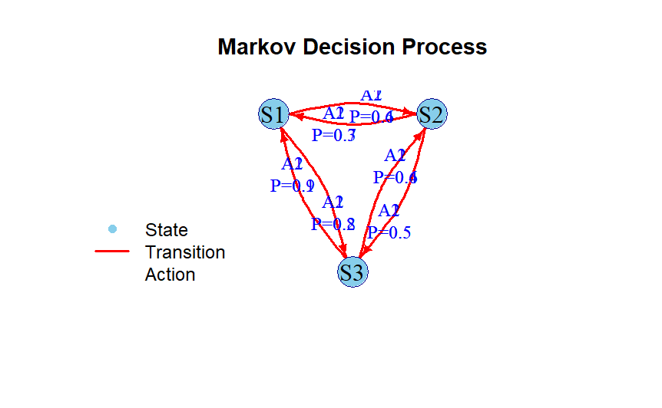
############################################################
> # MARKOV DECISION PROCESS (MDP)
> #############################################################
>
> #############################
> # MODULE 1
> #############################
>
> states <- c("S1","S2","S3")
> actions <- c("A1","A2")
>
> cat("Number of States :", length(states), "\n")
Number of States : 3
> cat("Number of Actions:", length(actions), "\n\n")
Number of Actions: 2

>
> cat("States:\n")
States:
> print(states)
[1] "S1" "S2" "S3"
>
> cat("\nActions:\n")

Actions:
> print(actions)
[1] "A1" "A2"
>
> # Transition Probabilities
> transition <- data.frame(
+ CurrentState=c("S1","S1","S1","S1",
+ "S2","S2","S2","S2",
+ "S3","S3","S3","S3"),
+
+ Action=c("A1","A2","A1","A2",
+ "A1","A2","A1","A2",
+ "A1","A2","A1","A2"),
+
+ NextState=c("S2","S2","S3","S3",
+ "S1","S1","S3","S3",
+ "S1","S1","S2","S2"),
+
+ Probability=c(0.6,0.4,0.2,0.8,
+ 0.7,0.3,0.5,0.5,
+ 0.9,0.1,0.4,0.6)
+ )
>
> cat("\nTransition Probabilities\n")

Transition Probabilities
> print(transition)
CurrentState Action NextState Probability
1 S1 A1 S2 0.6
2 S1 A2 S2 0.4
3 S1 A1 S3 0.2
4 S1 A2 S3 0.8
5 S2 A1 S1 0.7
6 S2 A2 S1 0.3
7 S2 A1 S3 0.5
8 S2 A2 S3 0.5
9 S3 A1 S1 0.9
10 S3 A2 S1 0.1
11 S3 A1 S2 0.4
12 S3 A2 S2 0.6
>
> # Rewards
> reward <- data.frame(
+ CurrentState=c("S1","S1","S1","S1",
+ "S2","S2","S2","S2",
+ "S3","S3","S3","S3"),
+
+ Action=c("A1","A2","A1","A2",
+ "A1","A2","A1","A2",
+ "A1","A2","A1","A2"),
+
+ NextState=c("S2","S2","S3","S3",
+ "S1","S1","S3","S3",
+ "S1","S1","S2","S2"),
+
+ Reward=c(5,10,-1,-5,
+ 3,7,2,1,
+ 4,6,0,-2)
+ )
>
> cat("\nReward Table\n")

Reward Table
> print(reward)
CurrentState Action NextState Reward
1 S1 A1 S2 5
2 S1 A2 S2 10
3 S1 A1 S3 -1
4 S1 A2 S3 -5
5 S2 A1 S1 3
6 S2 A2 S1 7
7 S2 A1 S3 2
8 S2 A2 S3 1
9 S3 A1 S1 4
10 S3 A2 S1 6
11 S3 A1 S2 0
12 S3 A2 S2 -2
>
> #############################################################
> # MODULE 2
> #############################################################
>
> A1 <- matrix(c(
+ 0,0.6,0.2,
+ 0.7,0,0.5,
+ 0.9,0.4,0
+ ),3,3,byrow=TRUE)
>
> rownames(A1) <- states
> colnames(A1) <- states
>
> cat("\nTransition Matrix for Action A1\n")

Transition Matrix for Action A1
> print(A1)
S1 S2 S3
S1 0.0 0.6 0.2
S2 0.7 0.0 0.5
S3 0.9 0.4 0.0
>
> A2 <- matrix(c(
+ 0,0.4,0.8,
+ 0.3,0,0.5,
+ 0.1,0.6,0
+ ),3,3,byrow=TRUE)
>
> rownames(A2) <- states
> colnames(A2) <- states
>
> cat("\nTransition Matrix for Action A2\n")

Transition Matrix for Action A2
> print(A2)
S1 S2 S3
S1 0.0 0.4 0.8
S2 0.3 0.0 0.5
S3 0.1 0.6 0.0
>
> #############################################################
> # MODULE 3
> #############################################################
>
> cat("\nReward Matrix\n")

Reward Matrix
> print(reward)
CurrentState Action NextState Reward
1 S1 A1 S2 5
2 S1 A2 S2 10
3 S1 A1 S3 -1
4 S1 A2 S3 -5
5 S2 A1 S1 3
6 S2 A2 S1 7
7 S2 A1 S3 2
8 S2 A2 S3 1
9 S3 A1 S1 4
10 S3 A2 S1 6
11 S3 A1 S2 0
12 S3 A2 S2 -2
>
> #############################################################
> # MODULE 4
> #############################################################
>
> eir <- merge(transition,reward)
>
> eir$ExpectedReward <- eir$Probability * eir$Reward
>
> cat("\nExpected Reward Calculation\n")

Expected Reward Calculation
> print(eir)
CurrentState Action NextState Probability Reward ExpectedReward
1 S1 A1 S2 0.6 5 3.0
2 S1 A1 S3 0.2 -1 -0.2
3 S1 A2 S2 0.4 10 4.0
4 S1 A2 S3 0.8 -5 -4.0
5 S2 A1 S1 0.7 3 2.1
6 S2 A1 S3 0.5 2 1.0
7 S2 A2 S1 0.3 7 2.1
8 S2 A2 S3 0.5 1 0.5
9 S3 A1 S1 0.9 4 3.6
10 S3 A1 S2 0.4 0 0.0
11 S3 A2 S1 0.1 6 0.6
12 S3 A2 S2 0.6 -2 -1.2
>
> summary_table <- aggregate(
+ ExpectedReward ~ CurrentState + Action,
+ data=eir,
+ sum)
>
> cat("\nExpected Immediate Reward\n")

Expected Immediate Reward
> print(summary_table)
CurrentState Action ExpectedReward
1 S1 A1 2.8
2 S2 A1 3.1
3 S3 A1 3.6
4 S1 A2 0.0
5 S2 A2 2.6
6 S3 A2 -0.6
>
> #############################################################
> #############################
> # MODULE 5
> #############################
>
> cat("\nSummary Table\n")

Summary Table
> print(summary_table)
CurrentState Action ExpectedReward
1 S1 A1 2.8
2 S2 A1 3.1
3 S3 A1 3.6
4 S1 A2 0.0
5 S2 A2 2.6
6 S3 A2 -0.6
>
> overall_summary <- sum(summary_table$ExpectedReward)
> cat("\nOverall Summary Value =", overall_summary, "\n")

Overall Summary Value = 11.5
>
> # Best Action for each state
> best_action <- do.call(rbind,
+ lapply(split(summary_table, summary_table$CurrentState),
+ function(x) x[which.max(x$ExpectedReward), ]))
>
> cat("\nBest Action for Each State\n")

Best Action for Each State
> print(best_action)
CurrentState Action ExpectedReward
S1 S1 A1 2.8
S2 S2 A1 3.1
S3 S3 A1 3.6
>
> library(igraph)
>
> edges <- data.frame(
+ from = transition$CurrentState,
+ to = transition$NextState,
+ label=paste0(
+ transition$Action,
+ "\nP=",
+ transition$Probability
+ )
+ )
>
> g <- graph_from_data_frame(edges, directed = TRUE)
>
> layout1 <- matrix(c(
+ 0,1,
+ 1,1,
+ 0.5,0
+ ), ncol=2, byrow=TRUE)
>
> plot(
+ g,
+ layout=layout1,
+ vertex.color="skyblue",
+ vertex.frame.color="darkblue",
+ vertex.size=40,
+ vertex.label.cex=1.3,
+ vertex.label.color="black",
+ edge.color="red",
+ edge.width=2,
+ edge.curved=0.25,
+ edge.label=E(g)$label,
+ edge.label.cex=1,
+ edge.label.color="blue",
+ edge.arrow.size=0.6,
+ main="Markov Decision Process"
+ )
>
> legend(
+ "bottomleft",
+ legend=c("State","Transition","Action"),
+ pch=c(19,NA,NA),
+ col=c("skyblue","red","blue"),
+ lty=c(NA,1,NA),
+ lwd=c(NA,2,NA),
+ bty="n"
+ )
>
> cat("\n=============================\n")

=============================
> cat("OPTIMAL POLICY\n")
OPTIMAL POLICY
> cat("=============================\n")
=============================
>
> for(i in 1:nrow(best_action))
+ {
+ cat(best_action$CurrentState[i],
+ " --> ",
+ best_action$Action[i],
+ " (Expected Reward = ",
+ best_action$ExpectedReward[i],")\n",sep="")
+ }
S1 --> A1 (Expected Reward = 2.8)
S2 --> A1 (Expected Reward = 3.1)
S3 --> A1 (Expected Reward = 3.6)

